Import Data
Step1:
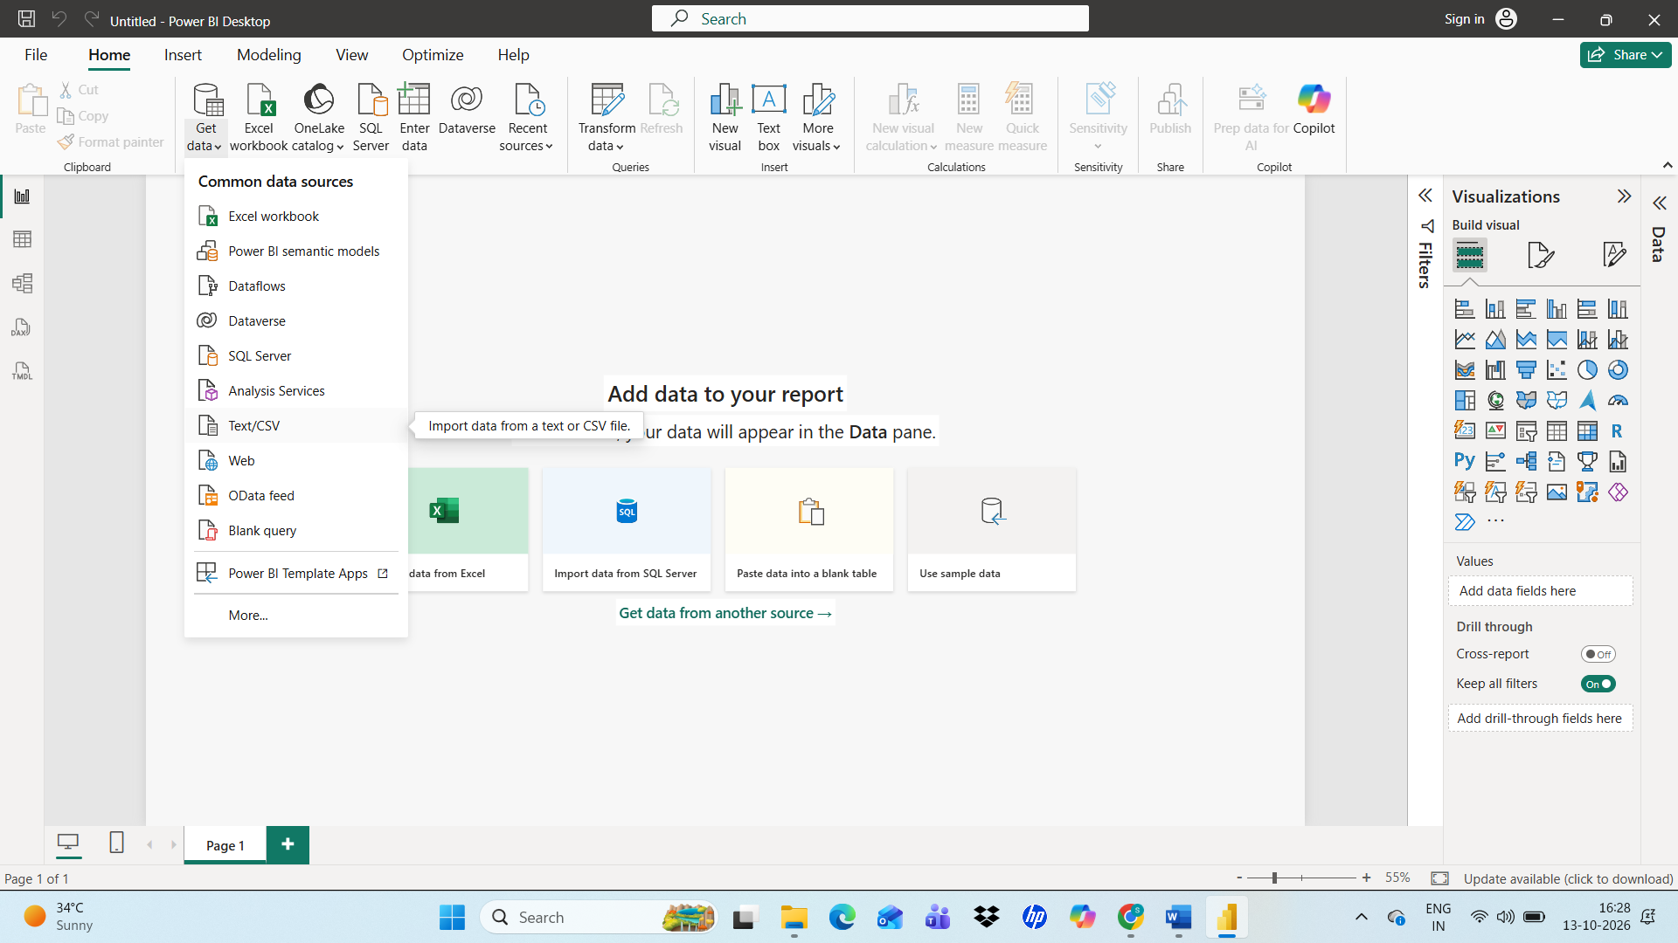
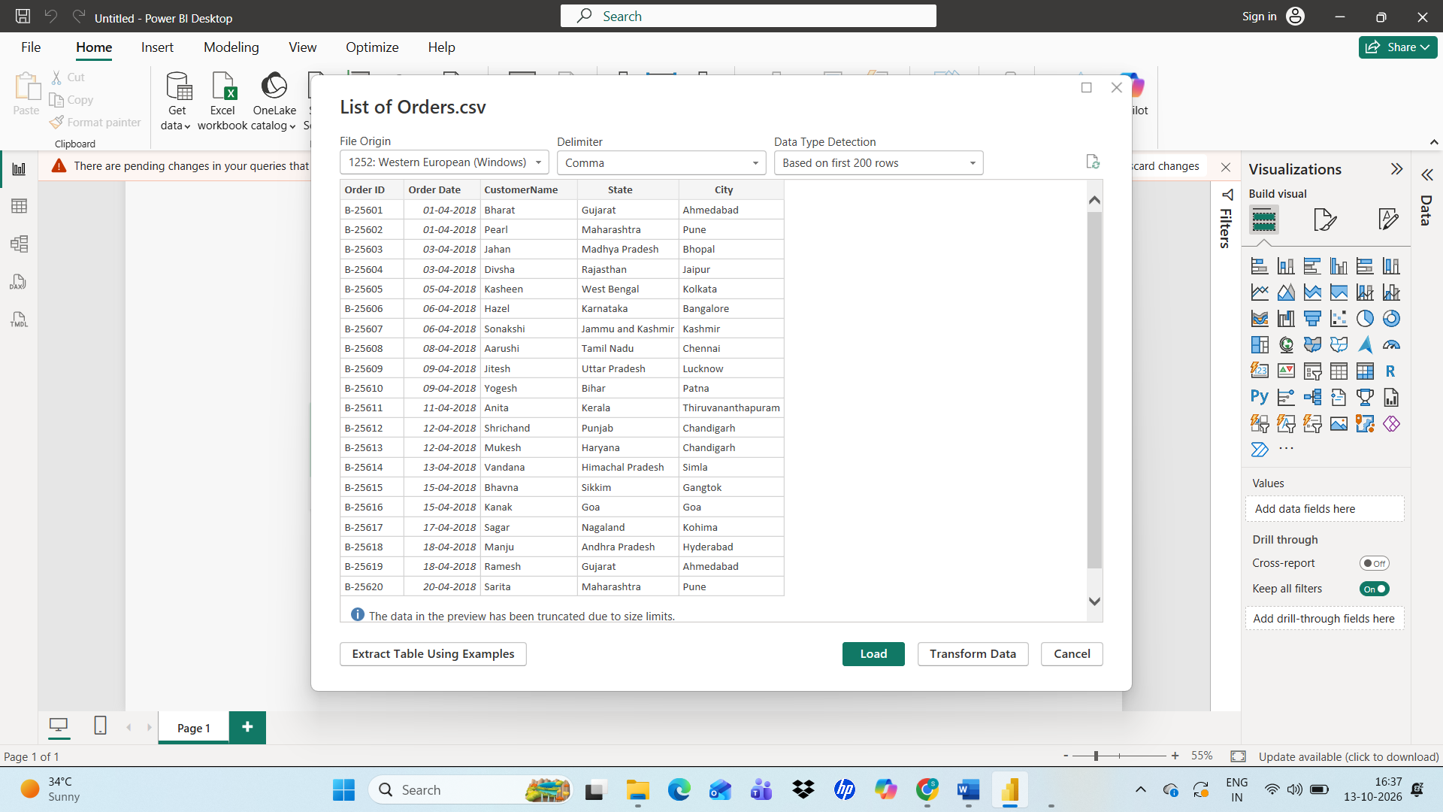
By using get data Import list orders, order details, Sales target into Power Bi as excel workbook

Data Transformation
Step2:
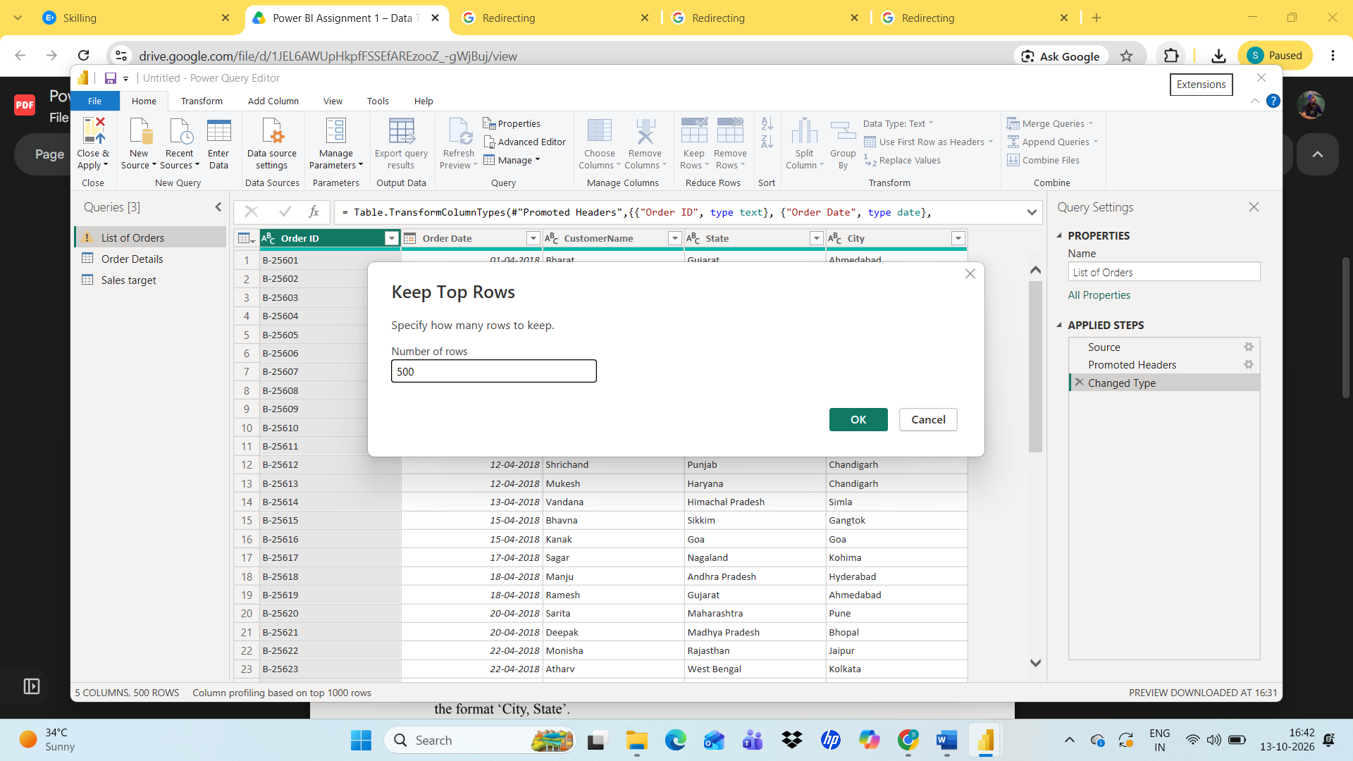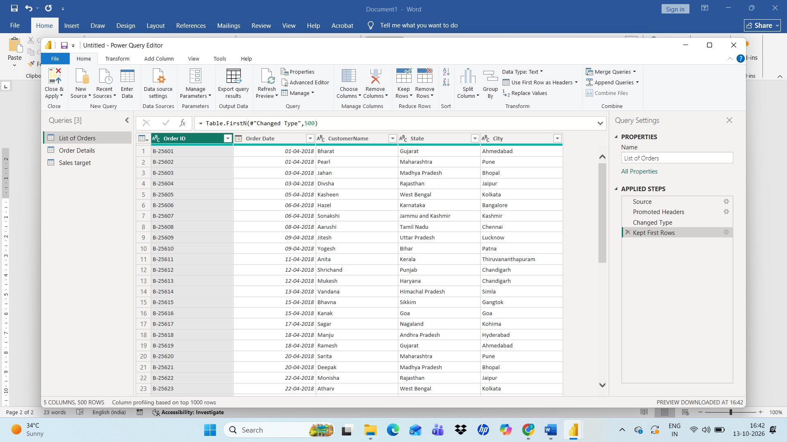
By using Keep rows keep the first 500 rows of List of orders
Step3:
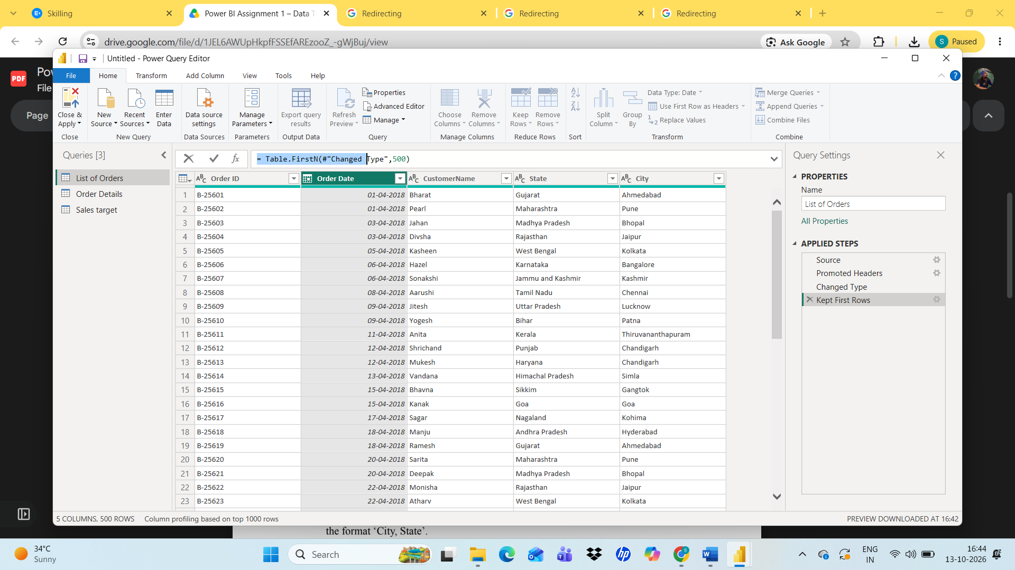checking Order date whether it was in correct Data type
Step4:
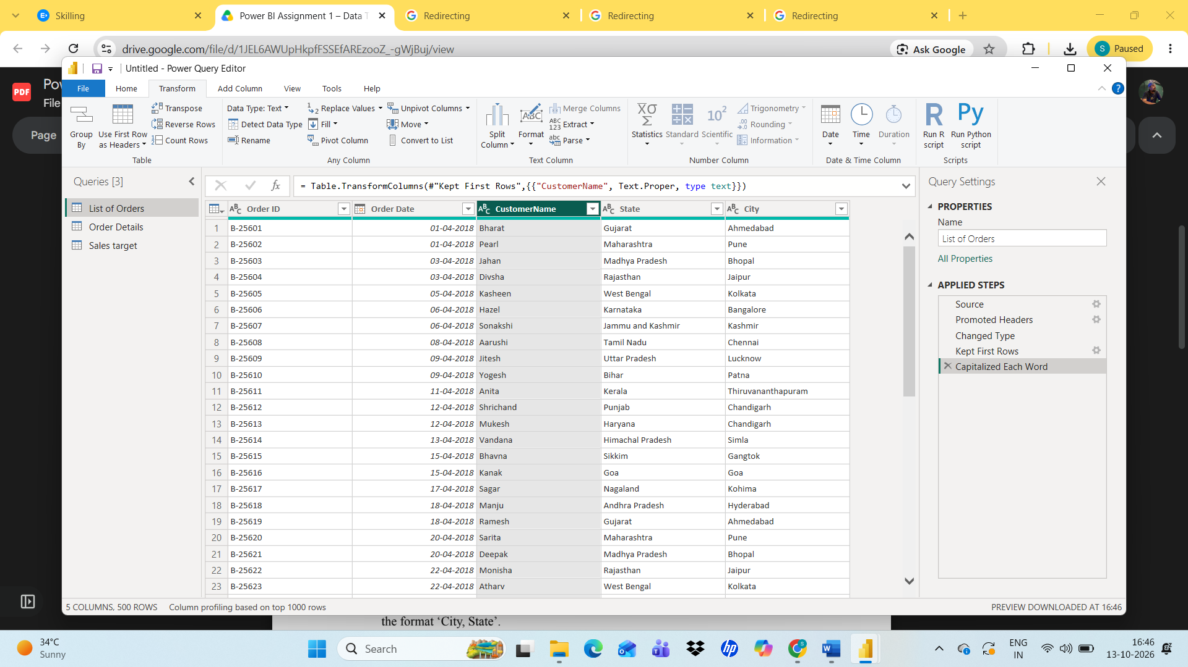
Covert customer into Proper by using capitalize each word

Step5:
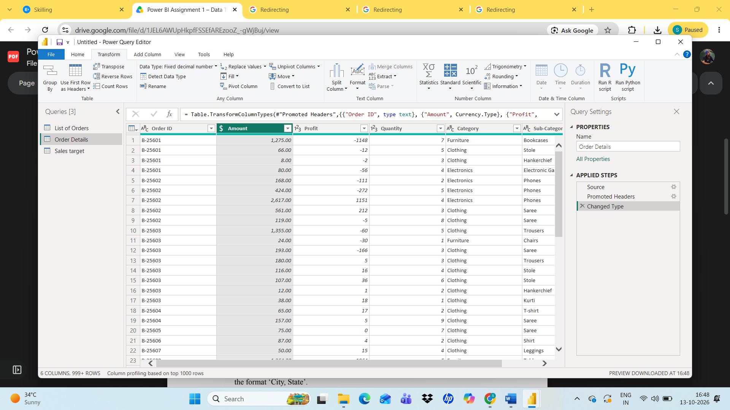
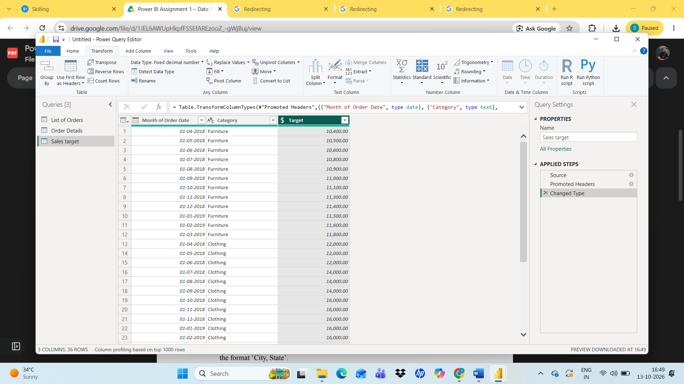
Covert Amount and Target into Fixed Decimal Number
Step6:
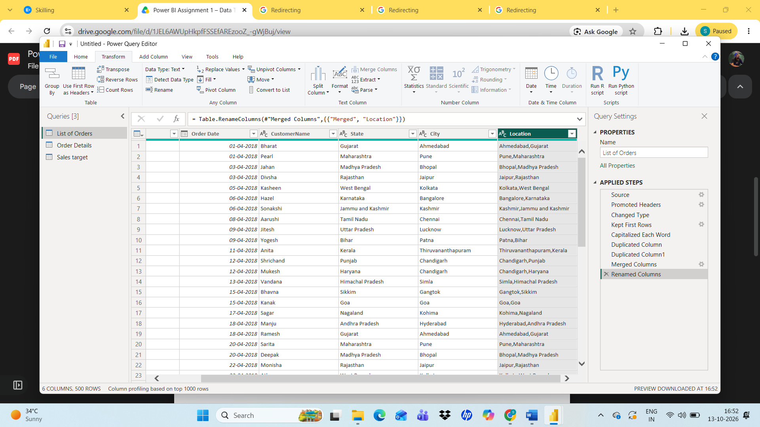
Created duplicate city and State column and using Merge column create a new column named location with the delimiter comma
Step8:
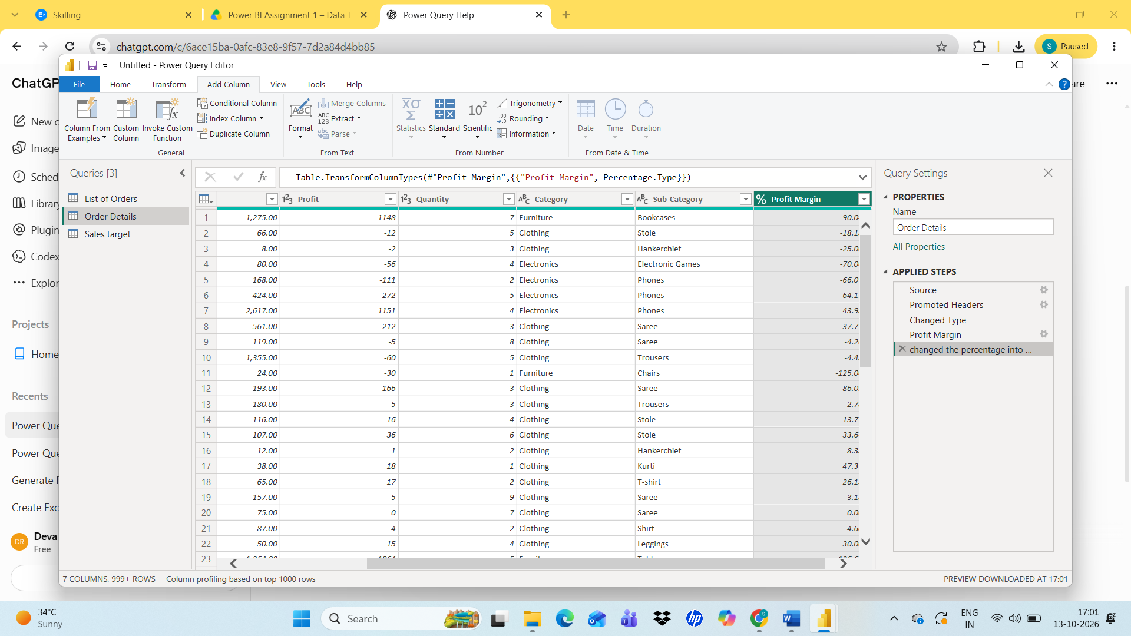
Create new column using Custom column named as Profit Margin with Profit/ Amount
Step 9:
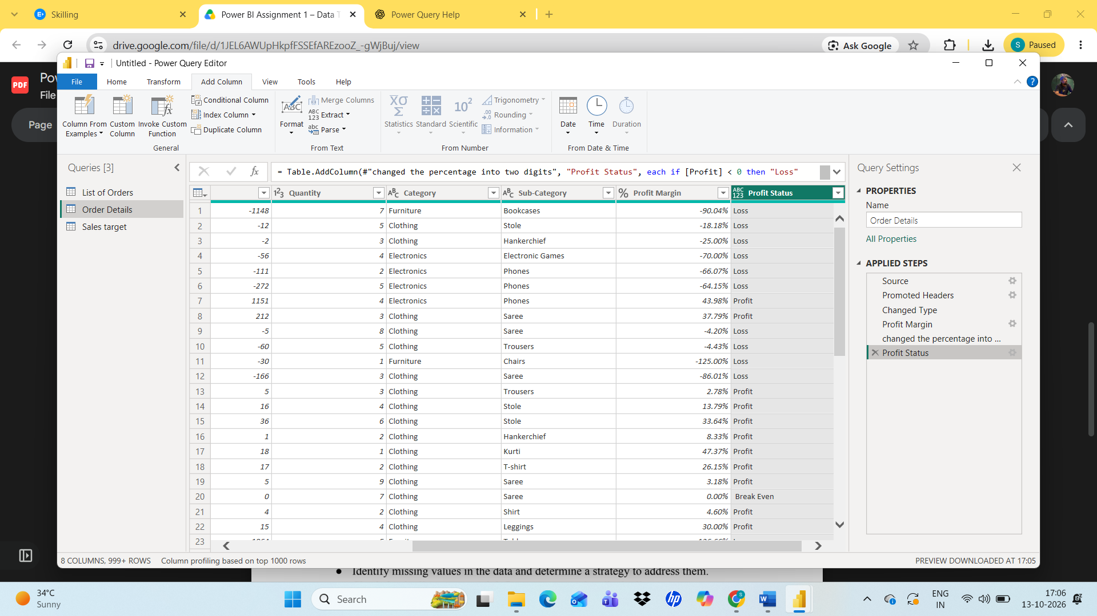
Create a conditional column named as Profit Status if the profit Less than 0 profit status should be Loss equals 0 Break even and Greater than 0 is Profit.

Merging Data
Step10:
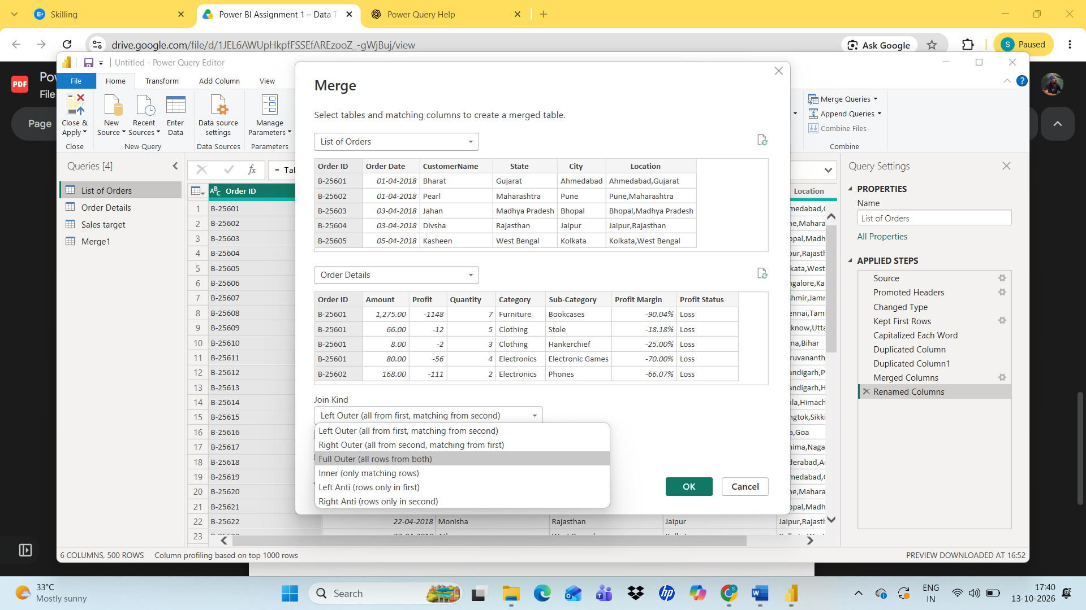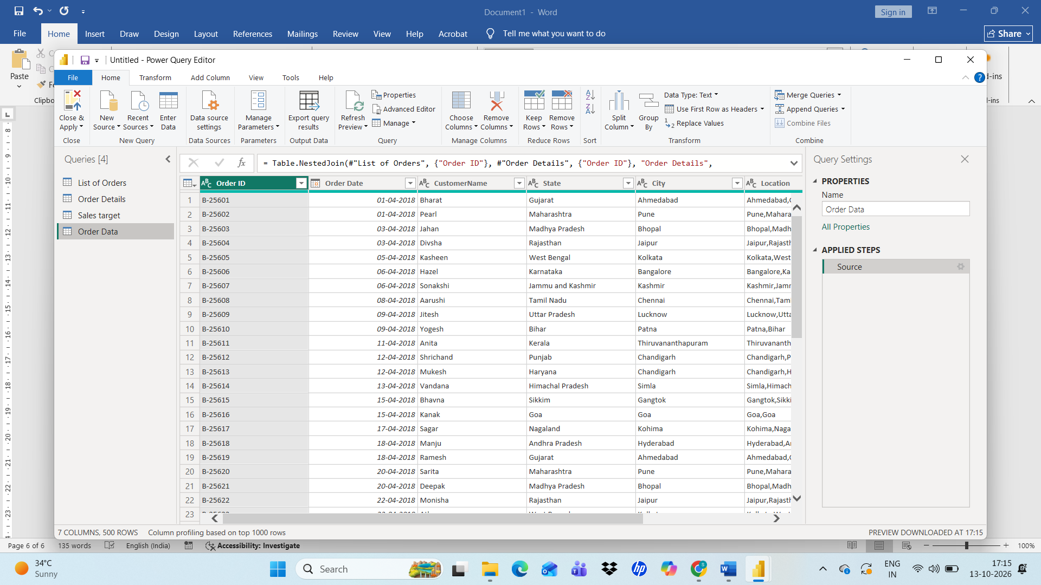
Using Merge queries merging list of orders and Order details Data into new Table named Order Data with the order ID relationship in Full outer

Handling Missing and Duplicate Data
Step11:
Checking for Missing and duplicate data by sorting filtering for each rows
No duplicate data found.

Sorting and Filtering Data
Step12:

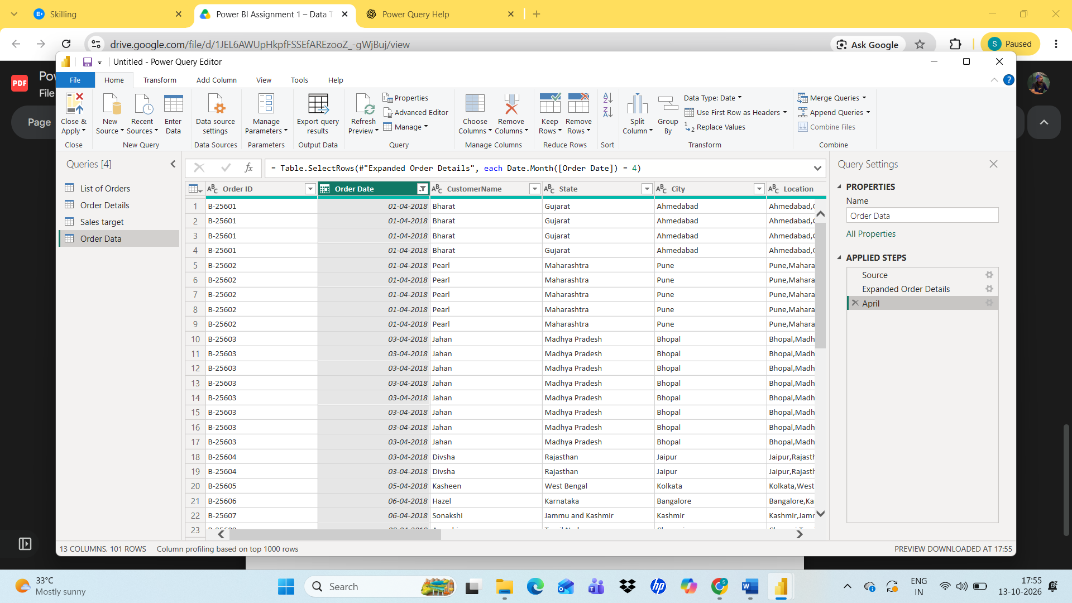
Filtered April month data to analyse each category in April Month
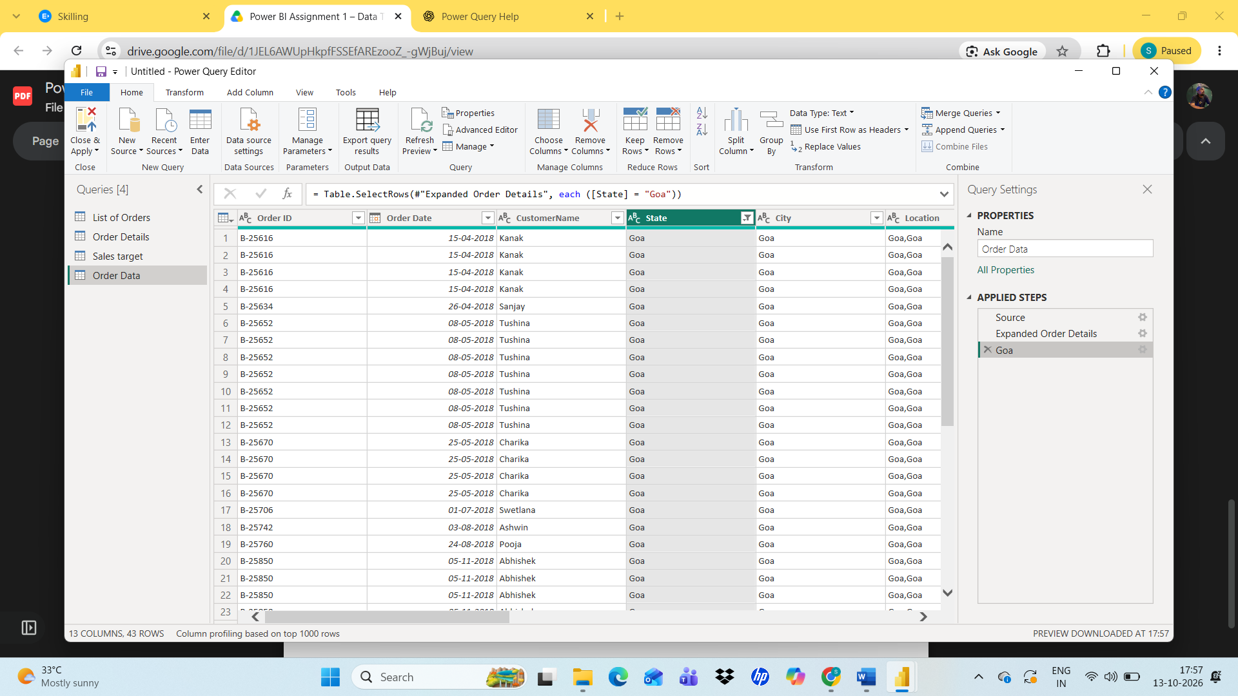
Filetered Goa state analyze Goa state Orders
Grouping And Appending Data
Step14:
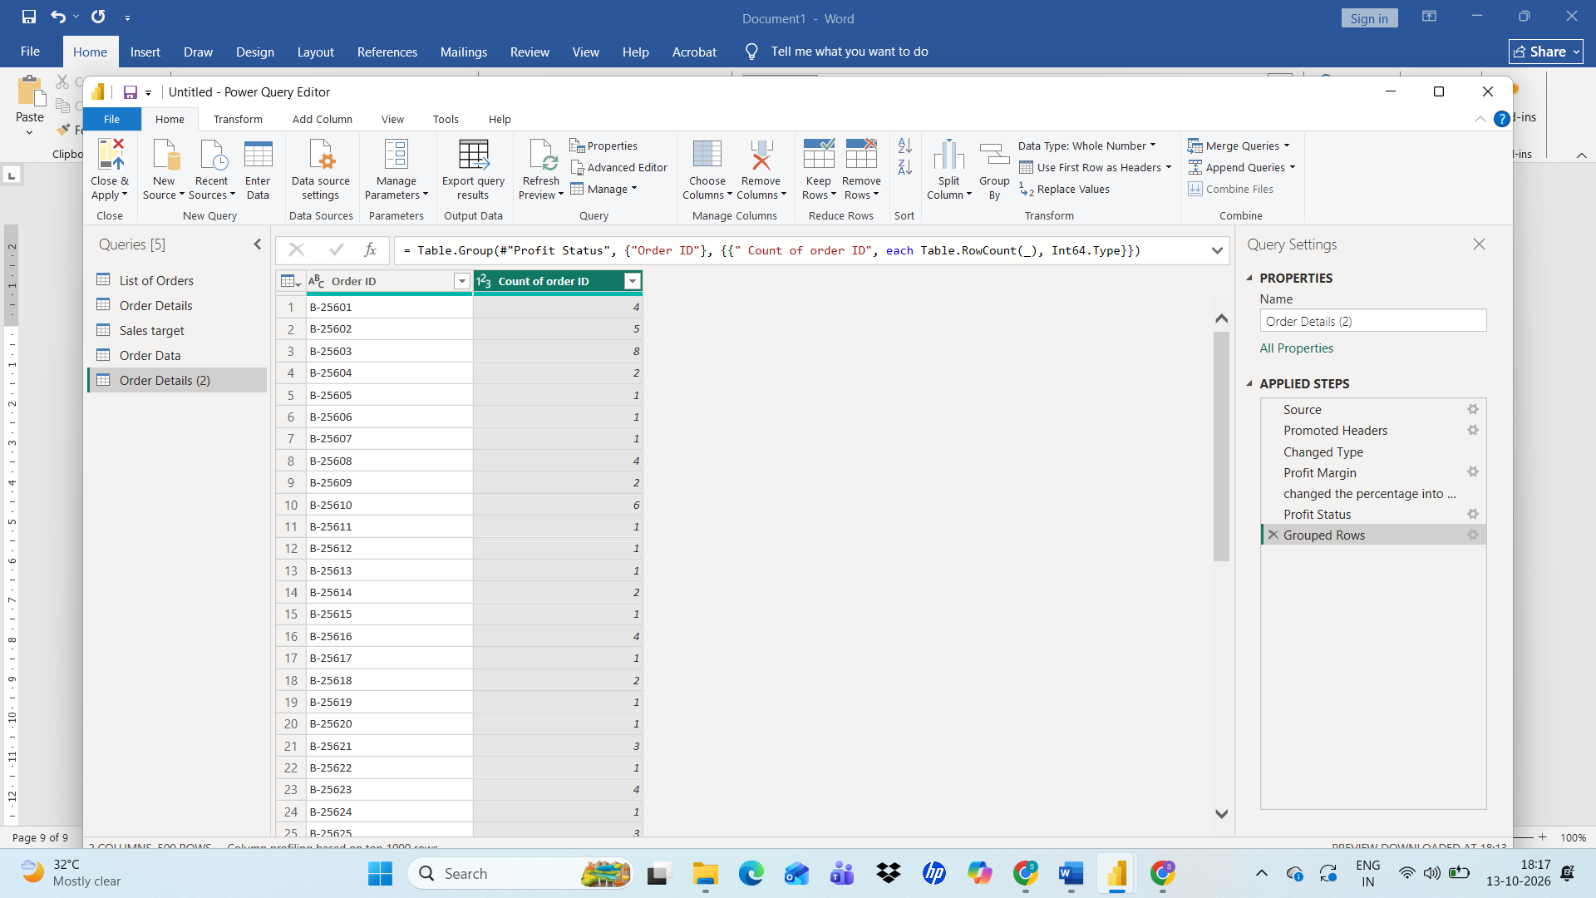
By using Group By Find the Count of the order id In Order details
Step16:
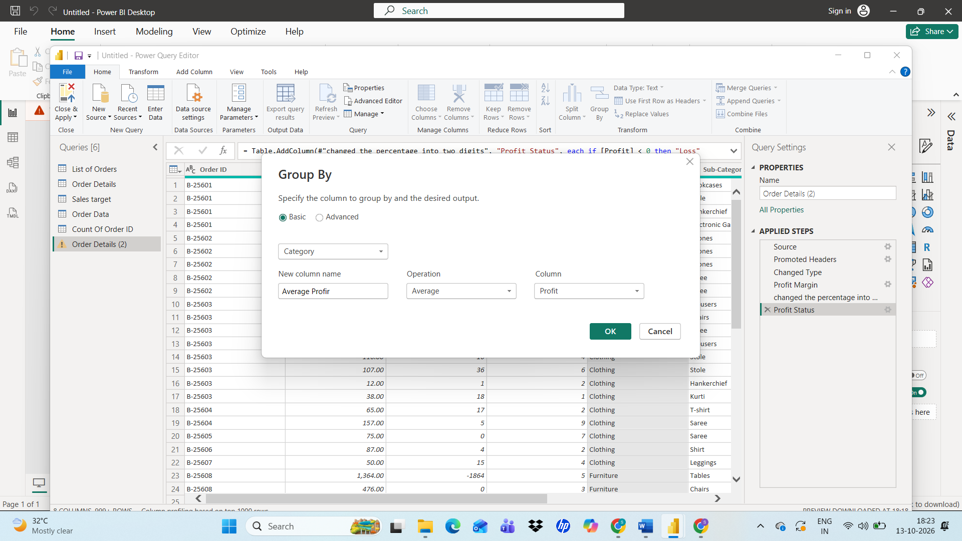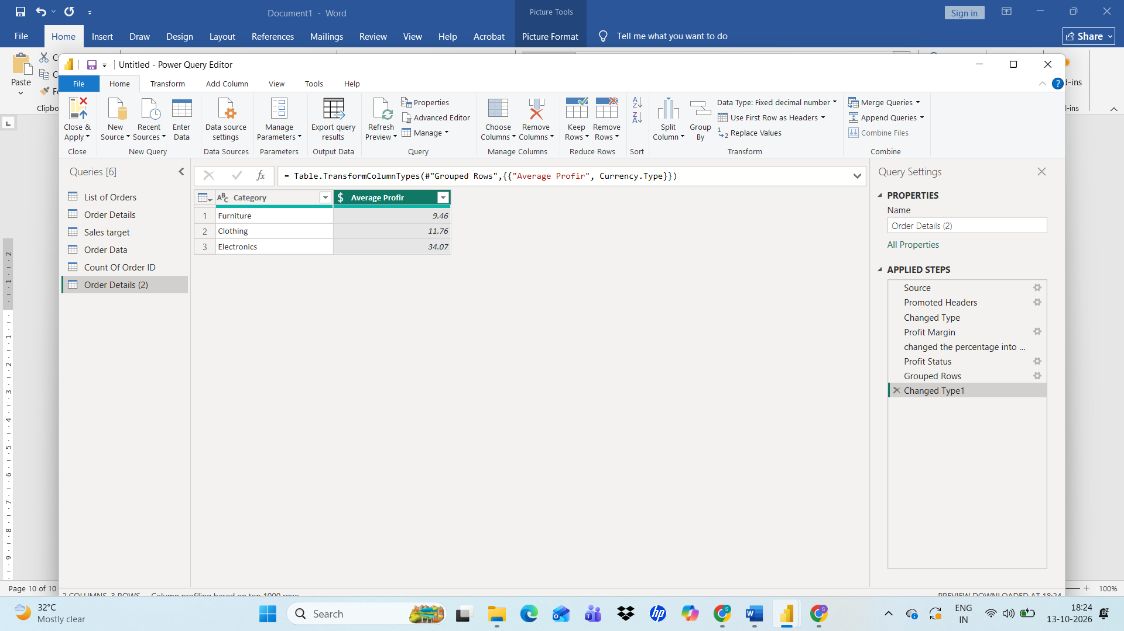

Finding Average profit of Each category Using Group By category finding Average of Profit new column named as Category Profit
Step 15:
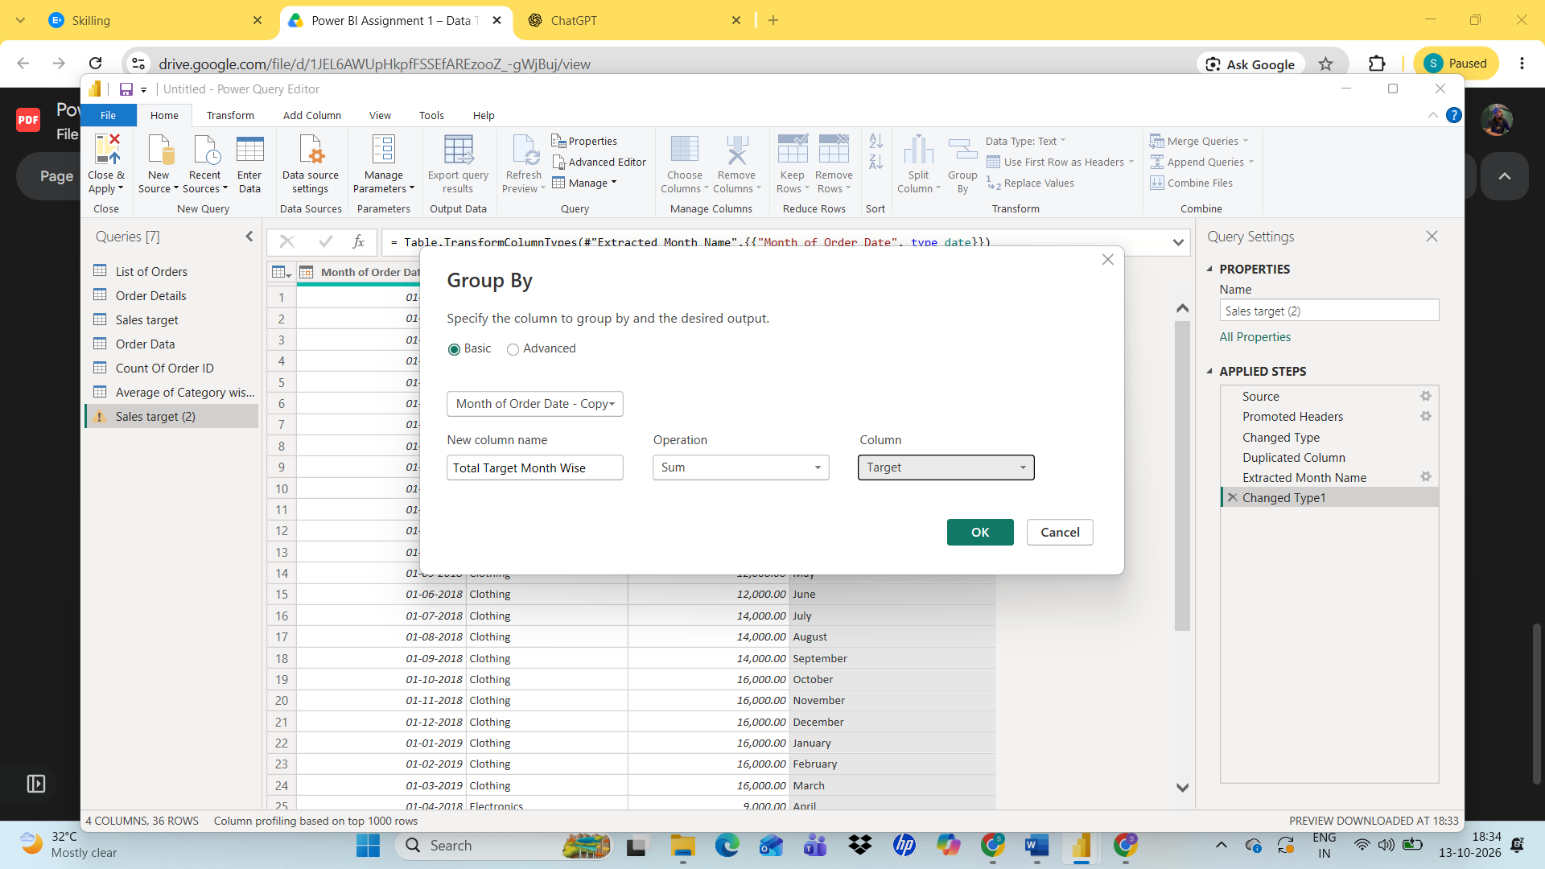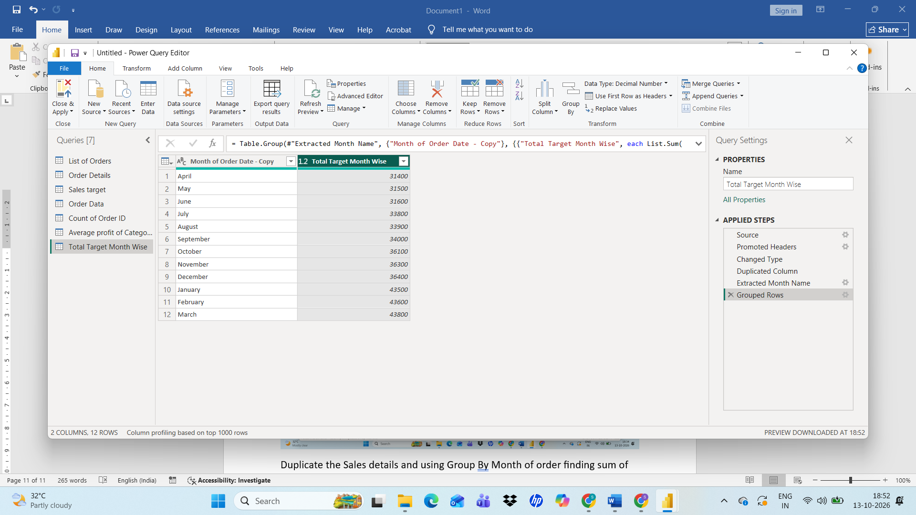
Duplicate the Sales details and using Group By Month of order finding sum of total order month Wise
Data Modelling
Step17:
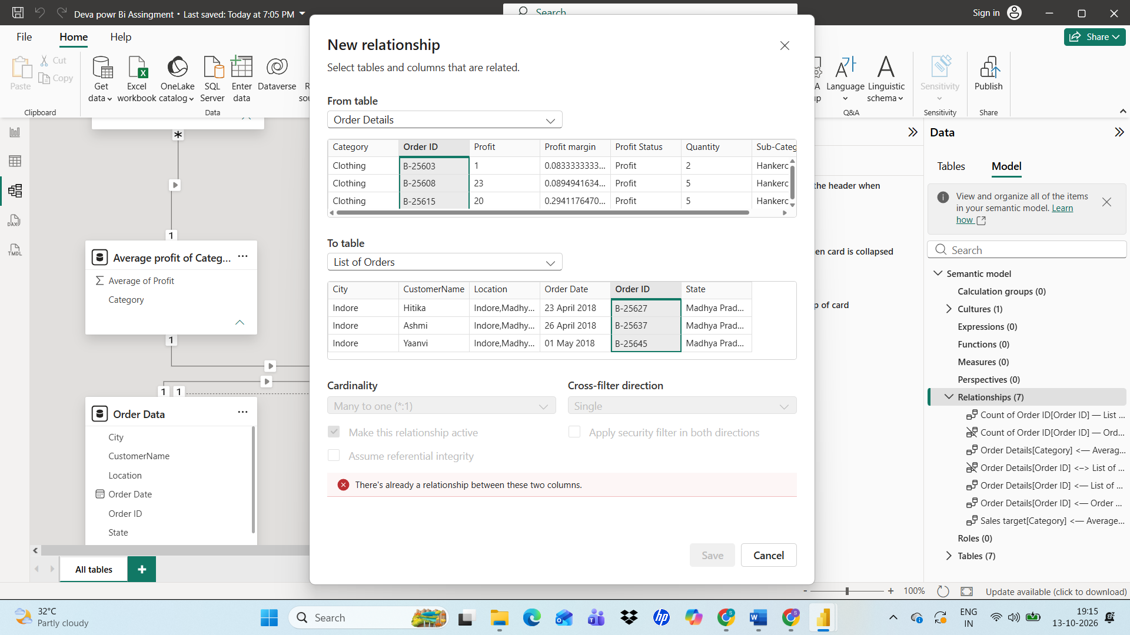
Finding the Relationship of List of Orders and order details with the Order ID
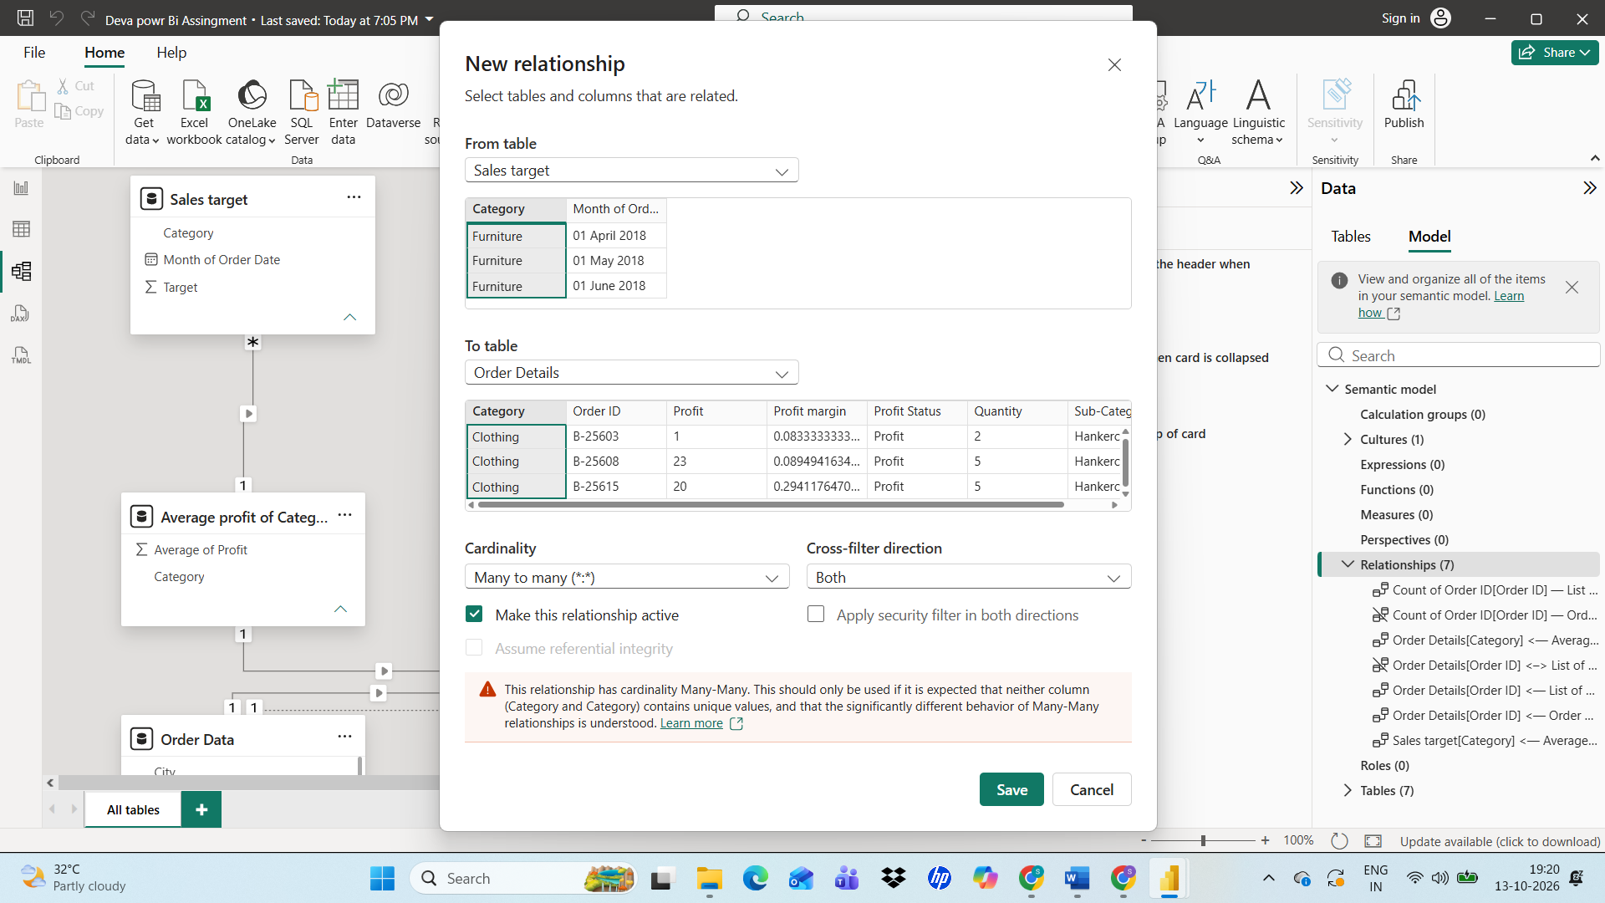
Finding the Relationship of list of order and S

